The First Part Last
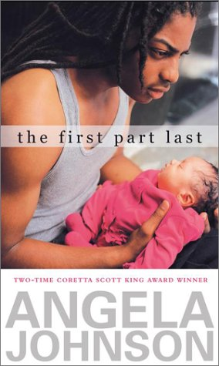

Reader’s Response Journal
Entry #3
Pages 50-86

Directions:
• Respond to 5 questions for this entry. Each response should be accompanied with at least 3-5 sentences of commentary and placed in your Readers Response Journal. Please follow the suggested format.

1. Analyze and interpret – “But in the end there was probably nothing I could do about anything anyway. If you look at it that way I guess it makes what goes down, go down easier” (51)
a). What is the “anything” that Bobby can’t prevent?
b). Why is he embracing this perspective?
c). What is “going down easier” for Bobby?

2. Hindsight is 20/20. How does this idea manifest itself in the following excerpt: “I should have hung with the first idea. Should have called off school and watched the big lizard with the kid all day” (53).

3. With regards to the “tagging incident” on pages 57-60, how does this event manifest Bobby’s conflict between the “Now” and “Then” of his life?

4. Bobby frequently references the “Ghost boy” on page 59. Why does he refer to himself in this manner?

5. With regard to the “tagging incident” on pages 57-60, critique Bobby’s parenting skills.

6. Bobby refers to the first chapter in Part II as a “fairy tale.” What is so perfect about this time (Then) especially in light of the present (Now)?

7. Who is the damsel, hero, and dragon in Bobby’s fairytale (pgs 66-68)?

8. With regard to pages 69-71, analyze and interpret the ironic clash of Bobby as parent and Bobby as adolescent.

9. Based on the following line and its surrounding context, is Bobby fit to be a parent: “Yeah, I guess so. All I want now is to go home, curl up in my bed, and sleep for two days” (73)?

10. Analyze and interpret the following exchange between Bobby and Nia:
“I know it was my fault.”
Nothing
“I can ‘fess to it. I was stupid” (77)
a). Why does Nia not respond?
b). What was stupid?
c). What is Bobby taking ownership of?

11. Analyze and interpret the following line: “I walk into the kitchen to make breakfast, and even though nothing’s changed yet, I miss her already” (79).

12. On pages 80-81, Bobby repeatedly says he feels old. Why is this the case? Explain

13. Unpack Bobby’s self-conflict in the following paragraph: “I watch everybody dancing, laughing, talking, and stuffing chips in their faces. I’m feeling like an alien. And it goes way past …” (83)

14. On pages 84-85, Nia and Bobby contemplate what to do with the baby. Analyze and interpret all of Bobby’s “I can’t answers” and “I can’t imagines.” What do these thoughts reveal about his readiness and willingness to parent a child?

15. With reference to pages 85-86, consider the following questions:
a). Does Bobby regret not pursuing an abortion?
b). What does Nia think is best for the baby?
c). Where does Bobby stand with regards to his baby?

