Misery
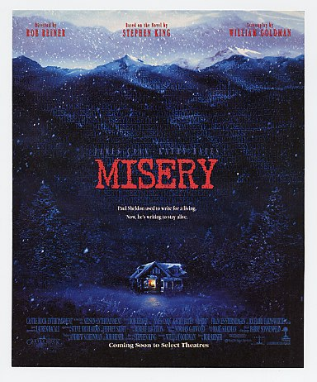
Reader’s Response
Entry # 2
Pages 38-61

Directions:
• Respond to 5 questions for this entry. Each response should be accompanied with at least 3-5 sentences of commentary and placed in your Readers Response Journal. Please follow the suggested format.

- Explain the context surrounding Paul’s thoughts and his present state of conflict: “It became something like a horse race. At first King of Pain was far in the lead and I Got the Hungries was some twelve furlongs back. Pretty Thirsty was nearly lost in the dust. Then, around sunup on the day she left, I Got the Hungries actually gave King of Pain a brief run for his money” (37).

- In the following passage Paul wishes for his death and alludes to the piling again. Why does he wish for his death and how does the symbol of the piling and tide work within this context: “He had spent much of the night alternately dozing and waking in a cold sweat, sure he was dying. After awhile he began to hope he was dying. Anything to be out of it. He’d never had any idea how bad hurting could get. The pilings grew and grew” (37).

- Analyze and interpret: “He stared with horror at what he had become below the knees. In his mind he heard the voice of Ronald Reagan in King’s Row, shrieking ‘Where’s the rest of me’” (38).

- Analyze and interpret the motivation behind the following scene: “He had to urinate. He laid the top sheet over his penis, hoping to create …(39).

- Analyze Paul’s thought processes in the following scene: “She looks like a widow who just got fucked after a ten-year dry spell” (40). Explain the circumstances that motivate such thinking.

- Explain the conflict in the following scene from both Paul’s and Annie’s perspective: “And sacrifice was what she had in mind of course- when she came back she was carrying the manuscript for Fast Cars, the only existing …” (42).

- Analyze and interpret Annie’s logic in the following remark to Paul: “The mother feels badly when her child says she’s mean or if he cries for what’s been taken away …” (43-44).

- With regard to the burning of the manuscript Annie explains to Paul – “But you must burn a few of the single pages, Paul – as a symbol of your understanding” (45). Explain the symbol as it pertains to Paul’s understanding.

- Does Paul have a true option with regards to burning Fast Cars? Use a quote to support your answer.

- Analyze and explain Paul’s sentiments with relation to the following event: “He swallowed them and lay back, thinking: I’m going to kill her” (48).

- In considering his “circle” Paul realizes the reality of his dilemma. Analyze what he means by the “circle” and relate it to his conflict – “They were miles … “ (51).

- Pages 51-56 contain Paul’s thoughts about the possibility of being rescued. Do you think somebody will discover him alive? Support your answer with reference to the text.

- Analyze Paul’s question: “If she had been clearly faced with the fact that she couldn’t destroy his ‘Dirty Book,’ might she not have decided to destroy the creator of the dirty book instead? After all, there was no copy of Paul Sheldon” (55).

- Analyze the conflicts embedded in the following questions: “How long before …” (58)

- Why does Paul think to himself: “If he could have reached it he would have patted it. If he could have reached it he would have kissed it” (59)?

- What motivates Paul to say things like – “It’s two of the letter in my favorite nurse’s name” (60)?

- Why did Annie buy the Royal typewriter? Use a quote to help support your answer.

