Fat Kid Rules the World
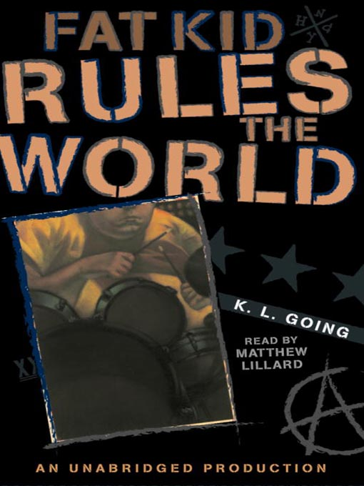

Reader’s Response Journal
Entry #2
Pages 32-69

Directions:
• Respond to 5 questions for this entry. Each response should be accompanied with at least 3-5 sentences of commentary and placed in your Readers Response Journal. Please follow the suggested format.

1. Analyze and interpret: “There’s something about the place that doesn’t seem right. It’s claustrophobic and chaotic at the same time” (34). What’s not right about this scene?

2. Based on page 34-35, argue that Curt either has a drug dependency or a legitimate need for prescription drugs.

3. Analyze and interpret the conflict of the following line: “Well, you’ve got a gig in five weeks” (35).

4. Unpack the source of Troy’s embarrassment – “I blush furiously. I do, but there’s something embarrassing about admitting it. Fat kids ought to be into groups that are kind of funny, right? Weezer? They Might be Giants?

5. What is Curt saying about the nature of music and our reasons for loving it – “Anyway, my point is, and this is the point I’m trying to make, is to like, right? Because we’ve all got our reasons for liking and if you don’t like what you like then you really aren’t liking” (39)?

6. On page 40, Troy juxtaposes Kelly Drexler’s 8th birthday party to Curt’s instrumental. What is the correlation? Base your response within the text.

7. Analyze and interpret the tensions that are pulling at Troy: “All the while it’s getting darker and darker, and in the back of my mind I’m worrying, truly I am, but I keep thinking, carpe fucking diem. I am the fat kid and I’m having fun” (41).

8. What does Troy mean by – “whoever made up that stupid ‘seize the day’ expression was never a teenager” (41)?

9. With regards to the incident on pages 42-44, Troy says – “I should be pissed” (44)
a). Why isn’t he?
b). Did Curt betray him? Support your answer with the text.

10. Analyze and interpret the source of Curt’s persistence: “Wait until we get your drum part in there, man. Oh, yeah. Couldn’t you hear it? I hear it in my head … while I’m playing. You’ll be perfect, T, perfect” (49).

11. Unpack the importance of Curt’s following comment: “Screw that! You make your own size. You make your walls. It’s not about what’s out there” (50).

12. As Curt and Troy decorate his room. Troy says “… for once in my life I forgot that I’m fat.” (52). What provokes this reaction?

13. Pull apart Troy’s rhetorical question and his reasoning – “No pictures … Dayle before what?” (53)

14. Is Troy’s dad’s statement warranted – “Troy, you are aware that your friend is a junkie, are you not” (54)?

15. Based on pages 54-55, and despite Troy’s resentment toward his brother and father, should he heed their advice? Refer directly to the text to support your answer.

16. Analyze and interpret the context surrounding the following lines: “He’s calling me a fat-ass, a tub of lard, shit-brained mother fucker’ but I don’t stop to argue. He’s probably right, but at least I’ve got my balls” (58).

17. Troy finally utters the truth – “I can’t be in a band with you. I can’t play the drums …” (59). Why doesn’t the truth grant Troy an exit out of his predicament?

