The Absolutely True Diary of a Part-Time Indian
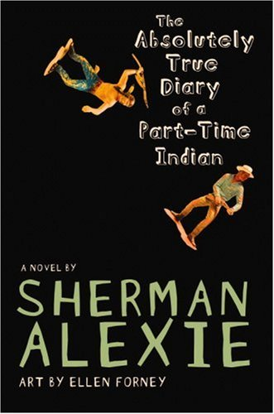
Reader’s Response Journal
Entry #2
Pages 44-81

Directions:
• Respond to 5 questions for this entry. Each response should be accompanied with at least 3-5 sentences of commentary and placed in your Readers Response Journal. Please follow the suggested format.

1. In response to Junior’s question – who has the most hope – his parents suggest that white people do. Explain this position and reasoning.

2. Explain the impact that race has on Junior’s decision to transfer to Reardan.

3. Mom states the “Indians around here are going to be angry with [Junior]” Analyze and interpret this reaction.

4. Based on Rowdy’s reaction on pages 51-53, to what extent does he perceive hope to be a white construct.

5. On pages 56-57, Junior dichotomizes the two worlds of the rez and Reardan and says “I didn’t deserve to be there. I knew it; all of those kids knew it. Indians don’t deserve shit” (56). Explain Junior’s self-conflict.

6. Analyze and interpret the implications of the following statement: “I felt brave all of a sudden. Yeah, maybe it was just a stupid and immature school yard fight. Or maybe it was the most important moment of my life. Maybe I was telling the world that I was no longer a human target” (65).

7. After the fight scene, consider one of our essential questions – who has the most hope?

8. Explain the irony of respect in the following situation: “Yes way! You see, you men and boys are like packs of wild dogs. The giant boy is the alpha male of the school, and you’re the new dog, so he pushed you around a bit to see how tough you are” (66).

9. Based on pages 71-72, analyze and interpret Eugene’s sense of respect for Junior.

10. Analyze and interpret: “I was so ashamed. I might have impressed the king, but the queen still hated me. I guess my grandmother didn’t know everything” (72).

11. With regards to Junior’s “love” for Dawn, consider one of our essential questions – “What becomes of the dreamers of the deferred dreams?”

12. Examine Junior’s twisted self-conflict in the following situation: “I was a poor kid raising money for other poor people. It made me feel almost honorable. But I just felt stupid and naïve after those guys took off” (79).

13. With regard to pages 80-81, why does Junior entertain the idea of Penelope so fondly?

