The Absolutely True Diary of a Part-Time Indian
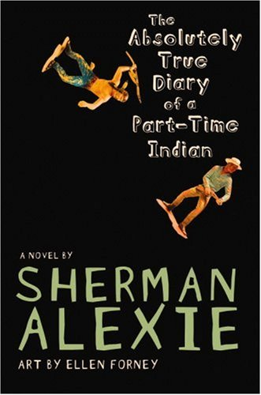
Reader’s Response Journal
Entry #1
Pages 1-43

Directions:
• Respond to 5 questions for this entry. Each response should be accompanied with at least 3-5 sentences of commentary and placed in your Readers Response Journal. Please follow the suggested format.

1. What does the following excerpt reveal about our narrator’s characterization – “But that makes the whole thing sound weirdo and funny, like my brain was a giant French Fry, so it seems more serious and poetic and accurate to say, ‘I was born with water on the brain” (2)?

2. Based on pages 2-4, analyze and interpret Junior’s sense of self.

3. What place does art serve in Junior’s life. Defend your answer with a direct textual reference.

4. Analyze and interpret the underlying conflicts of the following admission: “And sure, Oscar was only an adopted stray mutt, but he was the only living thing that I could depend on. He was more dependable than my parents, grandmother, aunts, uncles, cousins, and big sister. He taught me more than any teachers ever did” (9).

5. Explain the sense of “want” in Junior’s conflict: “I wanted to hate him for his weakness. I wanted to hate Dad and Mom for our poverty. I wanted to blame them for my sick dog and for all the other sickness in the world” (11).

6. What does the following admission foreshadow about Junior’s dreams? Moreover, what element does race play when dealing with dreams?
“Seriously, I know my mother and father had their dreams when they were kids. They dreamed about being something other than poor, but they never got the chance to anything because nobody paid attention to their dreams” (11)
7. Analyze and interpret the underlying conflicts of the following admission: “It sucks to be poor, and it sucks to feel that you somehow deserve to be poor. You start believing that you’re poor because you’re stupid and ugly. And then you start believing that you’re stupid and ugly …” (13)

8. Unpack the implications of the following statement: “I am a zero on the rez. And if you subtract zero from zero, you still have zero. So what’s the point of subtracting when the answer is always the same?” (16).

9. Analyze and interpret – “My hopes and dreams floated up in a mushroom cloud. What do you do when the world has declared nuclear war on you?” (31). What is the correlation between Junior’s sentiment and the geometry textbook?

10. On page 35, Mr. P. reminisces about the old days of teaching kids to “kill the Indian to save the child.” Explain this pedagogical position.

11. Why is Mr. P. apologizing to Junior when it was Junior who broke his nose? Use the text to support your answer.

12. With pages 37-39 in mind, place Junior’s sister beneath the lens of one of our essential questions – “What becomes of the dreamers of the deferred dreams?”

13. Analyze and interpret Junior’s sentiment and thought processes: “I almost gagged when I said that. I didn’t even believe that. There’s never enough time to change your life. You don’t get to change your life, period. Shit, maybe I was trying to write a romance novel” (140).

14. Of Rowdy, Junior says – “I don’t even know why he’s been nice” (41). Why is Rowdy nice to Junior?

15. Analyze and interpret the advice Mr. P. gives Junior on page 42-43.

16. Explain how the following equation functions – “You’re going to find more and more hope the farther and farther you walk away from this sad, sad, sad reservation” (43).

