Misery
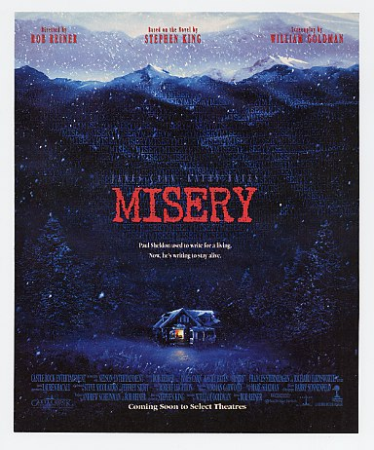
Reader’s Response
Entry # 1
Pages 3-37

Directions:
• Respond to 5 questions for this entry. Each response should be accompanied with at least 3-5 sentences of commentary and placed in your Readers Response Journal. Please follow the suggested format.

- The novel begins, “umber whunnn yerrrnnn umber whunnn fayunnn. These sounds: even in the haze” (3). Analyze and interpret what our narrator is referring to and the significance this has on the story.

- What does the following parenthetical statement reveal about the characterization of our narrator: “(That’s my name I’m Paulie and tonight ma’ll put Johnson’s Baby oil on my sunburn he thought inside the thunderhead where he now lived”(4)?

- The piling is mentioned is great detail on pages 4-6 and throughout the rest of the novel. How might this recollection serve as a symbol or metaphor for Paul’s current situation?

- What is the setting of the story? Use a quote to help support your answer.

- Chapter I: Section IV goes into great detail about Annie Wilkes’ character. How is she characterized? Use a quote to help support your answer

- How might Novril work as an antagonistic force in Paul Sheldon’s life? Use a quote to help support your answer.

- Unpack the motivation and desire behind Paul’s lie – “It’s just that my father always told me to keep my eye on my wallet” (10). Moreover, what does this say about the reliability of Paul’s storytelling?

- In recounting how Paul wound up in her house, Annie says – “That’s what makes it such a remarkable coincidence, don’t you see? (11). Explain the ‘remarkable coincidence.’

- Analyze and interpret the nature of the following question: “Why aren’t I in the hospital? This was clearly the question that wanted asking, but he wasn’t sure it was a question either of them wanted asked. Not yet, anyway” (11).

- In the following passage, analyze and interpret what troubles Paul about Annie’s demeanor: “There was a queer interval of silence, and Paul was frightened by what he saw on her face, because what he saw was nothing; the black nothing …”(12)

- Misery has two meanings for Annie Wilkes. Explain each while using a quote to support your answer. On the flip side, what does Misery mean to Paul Sheldon?

- Analyze and interpret: “For the first time, clearly, the thought surfaced in Paul Sheldon’s mind: I am in trouble here. This woman is not right” (14).

- Hindsight is 20/20. What led Paul to his current predicament and what should he have done? Use a quote to help support your answer.

- Paul asks, “Two weeks since you pulled me out?” (17) –
  - How long has it been since his accident?
  - How is it that he’s been able to stay alive during this time?
  - Paul merely broke his legs – why can’t he recollect the space between now and the car accident?

- Explain Annie’s reasoning – “You owe me your life, Paul. I hope you’ll remember that, I hope you’ll keep that in mind” (18).

- Analyze and interpret the following symbol: “She gave him the glass. It was cool and beaded with moisture. She kept the capsules. The capsules in her hand were the tide. She was the moon and she had brought the tide which would cover the pilings” (19).

- Analyze the following comment from both Paul’s and Annie’s perspective: “We are going to be very happy here,’ and although a bolt of horror ripped into his heart, Paul still did not open his eyes” (20).

- Analyze the following conflict: “She was crazy but he needed her” (21).

- With regards to his manuscript, Paul says to Annie – “Technique, that’s all it is. The subject … the subject dictates the form” (21). How does this idea relate to your own writing?

- What are Annie’s big objections to the manuscript for Fast Cars? Use a quote to help support your answer.

- On page 22 Annie and Paul disagree about the fact that language has context. Explain their disagreement. What does this event reveal about Annie’s character?

- Explain Annie’s logic – “But remember that you made the mess. Not me. It’s nobody’s fault but your own” (25).

- With regard to the bucket scene on page 25, consider the following:
  - Annie tells Paul, “Do it.” Why is she making this request?
  - Analyze and interpret: “Part of him groaned but none of him hesitated.”
  - Analyze and interpret the power Annie has over Paul as expressed in the following remark: “You won’t make me mad, again, will you?”
  - Interpret the symbol and Paul’s thinking: “Anger the moon which brought the tide? What an idea! What a bad idea.”

- While Annie is doing farm chores, Paul “remembered thinking: turn the pages of the manuscript into paper hats if you want, just … please …” (29). Describe the conflict Paul is having as a writer and as an individual fighting for survival.

- The preface of the book reads: “Goddess … Africa.” Meanwhile, while Paul is coming down from a Novril high we’re told – “An awful; memory bloomed there in the dark: his mother had taken him to the Boston Zoo, and he had been looking at a great bird …” (20). Literally and figuratively, analyze the significance of this flashback and its relationship to the preface.

- How might the following thought be a moment of foreshadowing: “Still trying to imagine why the ex-nurse who had taken him prisoner might have once been put on the stand in Denver, Paul drifted off to sleep” (31)?

- Based on pages 34-35, consider Misery Chastain’s death from Paul’s and Annie’s perspective. Why did Paul kill her? Why is Annie so upset?

- Based on Annie’s commentary on the bottom of 35 through the top of page 36 – to what extent do writers play god?

- Based on the novel’s preface, what does Paul mean when he thinks – “The distance between here and Denver was like … well, like the distance between the Boston Zoo and Africa” (37).

