The Earth, My Butt, and Other Big Round Things
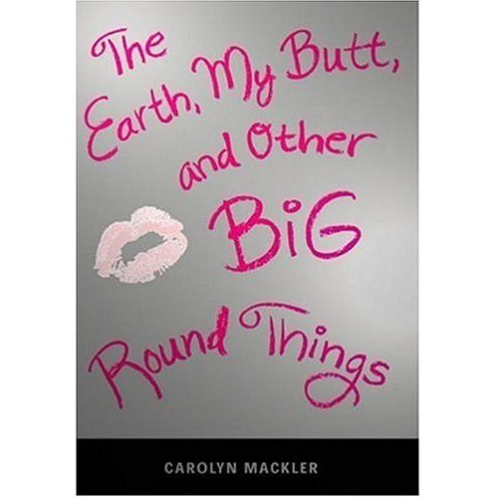

Reader’s Response Journal
Entry #1
Pages 1-20

Directions:
• Respond to 5 questions for this entry. Each response should be accompanied with at least 3-5 sentences of commentary and placed in your Readers Response Journal. Please follow the suggested format.

1. Analyze and interpret the following line: “I think it’s because we’re not boyfriend and girlfriend or even friends, for that matter” (4).
a). What is the exact nature of this “relationship?”
b). In an ideal world, what would Virginia ultimately want from this union?

2. Unpack the diction and conflict in the following line: “I can’t say it’s what I want, but I know this is all it can ever be” (4).

3. On page 6, Virginia details her kiss with Froggy. Analyze and interpret the various self-conflicts she endures in this moment.

4. In the following exchange between Froggy and Virginia, analyze the unspoken and spoken conflicts between them:
(Froggy) Don’t you want to …? Froggy’s voice cracks as he gestures in the direction of my boobs (7)
(Virginia) That’s not it. I point to the clock on my dresser. It’s just, you know, your trombone lesson (8).

5. What’s ironic about the following line: “I try to muster the courage to suggest we sit together at lunch sometime, but then I wimp out, say final yeah, and close the door” (8)?

6. During Anais’s “sex-talk” with her sister, she asks: “But do you know about guys” (10). What is she implying by this and what is the true answer from Virginia’s perspective?

7. Based on pages 10-11, what is the irony between Virginia’s mom’s profession and her parenting ability?

8. Anais said during her “sex-talk” – “If you can’t talk about something with a guy, you have no business doing it with him” (13). Has Virginia heeded this advice? Use specific textual references to support your claim.

9. Analyze and interpret the underlying conflicts at play in the following line: “When it comes to me, however, Anais failed to factor in one crucial thing. She forgot about the Fat Girl Code of Conduct” (14).

10. With regards to “The Fat Girl Code of Conduct” on pages 16-17:
a). How does Virginia’s issues with weight motivate the underlying tenets in all four rules?
b). Analyze and interpret the imagery and conflict of the following line: “Let him get the milk without having to buy the cow” (17).
c). Virginia says that the list is “brutally honest.” Do you agree? Explain

11. Why does Virginia entertain the following sentiment: “I have this theory that I was switched at birth” (17)?

12. On page 18, Virginia details her mother’s previous weight issues. Why, then, do you suppose the mother isn’t more supportive of Virginia?

13. Based on pages 18-21, how does Virginia’s family serve as a springboard for her low self-esteem? Use direct textual references to support your claims.

