The Catcher in the Rye

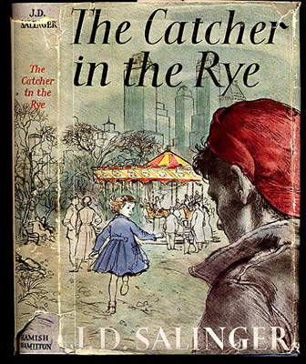

Readers Response Questions
Chapters 13-15
Entry #4

Directions:
• Respond to 3 questions for each chapter. Each response should be accompanied with at least 3-5 sentences of commentary and placed in your Readers Response Journal. Please follow the suggested format.

Chapter 13

- Analyze and interpret Holden’s statement: “Finally, though, I’d leave his room without even taking a sock at him. I’d probably go down to the can and sneak a cigarette and watch myself getting tough in the mirror”(89).

- Analyze and interpret Holden’s statement in relation to his character: “Some guys spend days looking for something they lost. I never seem to have anything that if I lost it I’d care too much”(89)

- Analyze and interpret: “It’s no fun to be yellow”(89).

- Holden explains to us that he is still a virgin. What is his rationale for this? Use a quote to help support your answer.

- Analyze and interpret: “The trouble is, I get to feeling sorry for them. I mean most girls are so dumb and all. After you neck them for a while, you can really watch them losing their brains. You take a girl when she really gets passionate, she just hasn’t any brains”(92).

- What does a violin, sex, and Holden have in common? Use a quote to help support your answer.

- Analyze and interpret Holden’s sentiment: “Sexy was about the last thing I was feeling. I felt much more depressed than sexy”(95).

- Holden asks Sunny, “Don’t you feel like talking for a while?”(95). Why does Holden feel so much like talking in a time like this? Use textual references to help support your answer.

- Holden tells us upon hanging Sunny’s dress, “The salesman probably just thought she was a regular girl when she bought it. It made me feel sad as hell – I don’t know why exactly”(96). Play Freud on Holden – Why does he feel this way?

- Holden tells Sunny, “I don’t feel very much like myself tonight ... but do you mind very much if we don’t do it?”(96). What is Holden’s reasoning for not “doing it” with Sunny? Use a quote to help support your answer.

Chapter14

- Explain Holden’s thought process in the following passage: “I felt so depressed, you can’t imagine. What I did, I started talking, sort of out loud, to Allie. I do that sometimes when I get very depressed and keep telling him to go home and get his bike and meet me in front of Bobby Fallen’s house”(98).

- What is Holden’s “beef” with the Disciples? Use a quote to help support your answer.

- In an earlier passage Holden tells us, “It’s no fun to be yellow”(89). With reference to his mishap with Maurice and Sunny, is Holden yellow? Use a quote to help support your answer.

- Holden tells us, “What I really felt like, though, was committing suicide. I felt like jumping out the window. I probably would’ve done it, too, if I’d been sure somebody’d cover me up as soon as I landed. I didn’t want a bunch of rubbernecks looking at me when I was all gory”(104).
  - Analyze and interpret Holden’s “rubberneck” sentiments
  - Would Holden actually commit suicide? Support your answer by using direct textual references.

Chapter 15

- Holden makes plans with Sally Hayes to see a matinee. He refers to her as a phony and a pain in the ass. Why, then, would he have any interest in spending time with her?

- What does the following statement reveal about Holden’s character: “It isn’t important, I know, but I hate it when somebody has cheap suitcases. It sounds terrible to say it, but I can even get to hate somebody, just looking at them, if they have cheap suitcases with them”(108).

- Holden has a strange impulse to give the two nuns in the diner $10-. Since we know he is low on money, what do you believe his motivations are in doing this?

- Literary critics have often noted that Holden’s social interactions are strained because he maintains so many preconceived notions about people. Support this claim by referring to a particular moment within the text.

- What is Holden’s particular grievance against Catholics? Use a quote to help support your answer.

