Fat Kid Rules the World
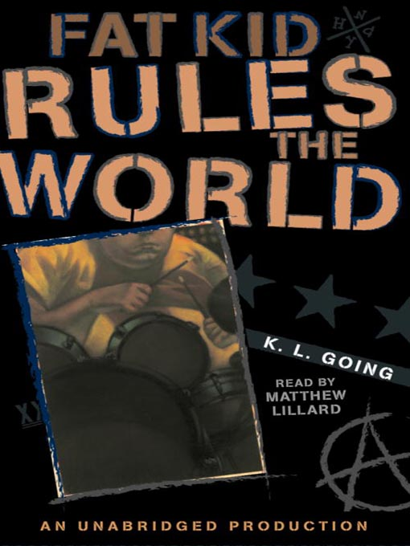

Reader’s Response Journal
Entry #1
Pages 1-32

Directions:
• Respond to 5 questions for this entry. Each response should be accompanied with at least 3-5 sentences of commentary and placed in your Readers Response Journal. Please follow the suggested format.

1. The first paragraph of the book exclusively focuses on the protagonist’s self-characterization. If we look beneath the surface, what kind of kid are we dealing with? Support your answer by referring to the text.

2. Unpack the conflict and context of the following question: “Would it be funny if the fat kid got splattered by a subway train? Is that funny? (1).

3. Analyze and interpret the irony of the following line: “I start laugh. Suddenly there’s something funny about it. I swear to god. There really is” (2).

4. Based on Curt’s characterization on pages 3-4, how might he serve as a foil character to Troy?

5. Analyze and interpret the source of Troy’s confusion: “I just saved your life. It’s the least you could do” (4).

6. What is the waitress implying with her question and how does it ironically link to Troy’s silent thought – “Are you sure” (6)?

7. On page 9, Curt , Curt rushes to the bathroom and announces he’s ill. What do you suppose is the cause of his frailty and illness? Is Troy’s hypothesis of “shooting up” accurate?

8. What prompts Curt to announce, “This isn’t some after-school special where you learn to love yourself by saving my sorry ass. I saved you, remember? Let’s keep that straight” (11)

9. Analyze the source of Troy’s transformation – “Curt keeps talking, but the conversation is over. All I do is grin, hoping he’ll say it just one more time (14).

10. Analyze and interpret the conflict: “Dayle takes one look at Curt and knows I’ve done the wrong thing. Two roads diverged in a yellow wood and Dayle wishes I’d taken the one that ended in front of the train” (18).

11. On pages 18-22, Curt meets Troy’s family. From each person’s perspective, analyze why the scene is tense and awkward.

12. Analyze and interpret Troy’s motivation: “I could drop the lie right there, but I don’t” (22).

13. Answer Troy’s question – “What kind of person lies about being in a band when it’s obvious that this is absurd? I mean, what the hell was I thinking? What did I imagine would happen? (23).

14. Analyze and interpret the following scene: “The question is so totally unrelated I think I’ve heard him incorrectly. I don’t respond and he coughs, almost as an afterthought. I shake my head. Curt shrugs and the mood pops like a cherry” (27).

15. Analyze and interpret: “Maybe everyone’s waiting for him to deliver the punch-line. Did you really think I wanted to form a band with you” (31)
a). What self-conflicts are fueling Troy’s self-doubt?
b). Why is Curt so deadest on having Troy be his drummer?

