Joe Mama
Mr. Kuhn
AP Language and Composition
Tuesday, March 8 2010

Is Prayer A Psychological Placebo?

Through the course of history there have been many accounts were a prayer has been answered with a miracle , something that science cannot explain. In the same time there has been an exceedingly larger number of cases were prayer has been "answered" though, through no miracle or real noticeable change in a person's life. Indisputably prayer has proven that it affects human lifestyle and encourages them in their everyday problems and sometimes in their health through thaumaturgical means. Prayer, a reverent petition made to God, has been subject to one of the most controversial arguments in the field of science, medicine and religion; is prayer really nothing more than a psychological placebo resembling practices of meditation or is there a divine deity which interferes through miracles and supernatural occurrences? Though the debate favors both extremes I will go along the lines that both indeed coincide and through testimonies and studies upon the fields of psychology, theology and behavioral medicine I will discuss the mystical practice of prayer.
Prayer could be no different than any other form of meditation , acting as a psychological placebo for relaxation and rumination, thus leading to a stress free attitude that may promote general well being and openness in addressing commonly encountered problems. Although there are several types of prayer, the experimental study Prayer and Subjective Well-Being: An Examination of Six Different Types of Prayer , completed a measure of six prayer types out which adoration, thanksgiving and reception showed the most significant effect towards a positive mind-set. The psychological outcomes of these types of prayer could be subjective well being, self-esteem, optimism and meaning in life. Table 3 reports the results of regression analyses where each of the six prayer types were simultaneously regressed on psychological outcomes (Brandon L. Whittington and Steven J. Scher 64) 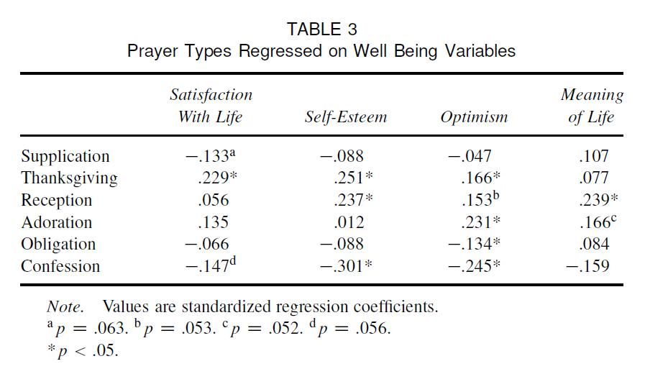

Each prayer may seem similar but each one serves a different purpose; adoration , a pure worship of God without reference to specific events or needs; thanksgiving , giving thanks to God for specific positive outcomes or circumstances; and prayers of reception , prayers focused on opening oneself up to closeness with God (64). This optimistic frame of mind a person during prayer has, could be correlated with the low brain waves transmitted made visible through an electroencephalogram. In the book The psychology of religion: an empirical approach by Bernard Spilka , Bernard highlights a noticeable fact that since prayer involves ritual, the neurobiological correlates of ritual may also hold for prayer (65). That is, a ritual corroborates for the low brain waves transmitted because of the established ceremonial method which promotes tranquility . Transcendental Meditation also employs a unique technique which follows a somewhat ceremonial procedure that nonetheless encourages tranquility. One could infer that seeing as prayer may induce relaxation(66) it may well be juxtaposed with Yoga and Zen meditation [that] have been associated with the production of alpha brain waves , which occur with feelings of well being (65) thus also inducing relaxation. Taking a time off during your day at work to unwind and just pray, could give you that psychological boost you need to face your daily problems, a very similar practice of other working people carrying out Yoga exercises during their breaks for stress release. Since there is evidence that both meditation and prayer have similar results , it may well be that prayer "answers" are merely a placebo effect that enables an optimistic self-worthy mind-set through relaxation and reflection.
Though meditation and prayer shows similar results, studies have shown that prayer is by far the most popular alternative and complementary technique of medicine, creating a large percentage gap between the two, giving rise to the inquiry of interference of God through miraculous events and supernatural communications. Alternative medicine is any sort of healing arts not taught in traditional Western medical schools that promote options to conventional medicine that is taught in these schools (Medterms.com). Among these alternative medicine practices, recognized universally by all health organizations , prayer is the most popular making many "doctors say that's reason enough to ask patients about their spiritual belief". The really high percentage 55.3% of prayer for health reasons shown in Table 2 below showing the forms of complementary and alternative medicine techniques (CAM) in the United States in 2002, creates a huge chasm between prayer and meditation which is rated at 10.2%. Since prayer and meditation have similar psychological effects leading to physiological well being, what makes the difference and prayer has such a crashing higher percentage?
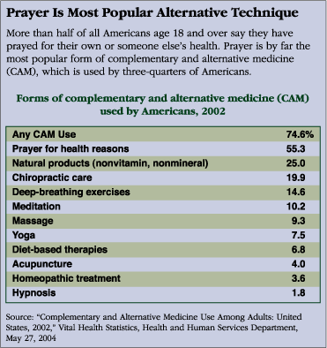

Many argue that due to the fact that most people in the U.S. are in some sort of religion it is only logic that prayer is the most popular form of CAM. "Herbert Benson, an expert on the physical benefits of meditation suggests that praying — repeating phrases, words or motions — produces beneficial, stress-reducing physiological effects, such as lowered blood pressure, like those produced by meditation" (Sarah Glazer). But why would people keep on praying if the results are hypothetically analogous of that of meditation and yoga, since both do not require a certain belief to an austere image of religion? The truth may lie in the fact that prayer could be more effective due to a deity that has supernatural power and not only heals people through miracles but who also accounts for the daily serenity received by praying. In the article The Voice of God multiple testimonies have been recorded of people who have actually heard the voice of God and felt that "the Spirit of God communes with the believer and provides fellowship (comfort and peace) and direction" ( Dr. Simon Dein and Professor Roland Littlewood 2). According to the article, prayer acts as a means of communication from the person to God and He may respond through "modes of communication that are not mutually exclusive" such as dreams, words from scripture, sermons and even an audible voice. God communicates with each person in a unique manner, something that scientists have a hard time comprehending, as the nature of the subject does not allow for the collection of objective data. Since science cannot conclusively explain the phenomenon, this is considered by many a miracle. One of the testimonies state :“It is not like, when say for instance my body is telling me I am thirsty so I think in my mind, I think I will make myself a drink now. It is not like that. It is definitely something outside of me, talking to me.”(Dr. Simon Dein and Professor Roland Littlewood). There are thousands of testimonies and extracts from the Bible that describe such supernatural occurrences and even of greater magnitude; yet, none can provide sufficient scientific evidence to support the claim, thus the listing of such examples is redundant. The wide usage of prayer and its effects in its full spiritual and healing potential have not been understood yet by science showing that a higher divinity, God, can well be the reason for it.
All things considered, the effects of prayer, including providing mental stability and general welfare , are easier to interpret as those of a psychological placebo effect. However, prayer cannot be evaluated objectively since it is a very personal experience. Therefore, the true interpretation of prayer lies within each individual with the key determinant being faith in God.

"Works Cited"
- Bernard Spilka. The psychology of religion: an empirical approach , Book Print.

- Brandon L. Whittington ,Steven J. Scher. Prayer and Subjective Well-Being:An Examination of Six Different Types of Prayer , Print.

- Health and Human Services Department. Table of Complementary and Alternative Medicine Use Among Adults: United States, 2002

- Sarah Glazer. Prayer and Healing Can spirituality influence health? Article Print.

- Dr. Simon Dein, Professor Roland Littlewood. The voice of God , Print

