Go Ask Alice
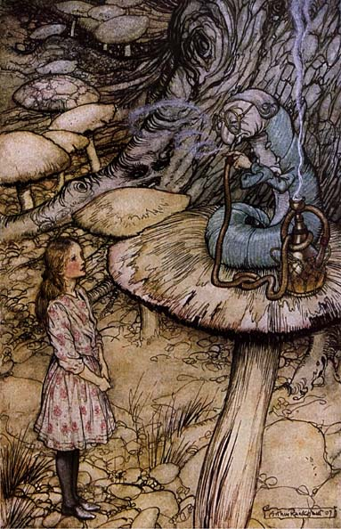

Position Paper
Situation: You work for a newspaper as an advice columnist. Our narrator has faxed you a large portion of her diary: pages 7-101. The cover sheet of the fax reads – “I’m 15 years old and this diary represents the crappy although terrific life I’ve been living the past few months. Please read and give me your advice on what I should do. P.S. I need you to be honest with me. Sincerely, Anonymous.”

Guidelines and Grading Criteria:
□ As an advice columnist, write to our narrator and give her some advice with regards to her life and present situation

□ Write in letter form and address your audience

□ Use a minimum of 5 quotations from pages 7-101 to support your ideas

□ Pay attention to your sentence length, sentence openers, and “To Be” verb usage

□ Be thorough (Anything less than 2 pages doesn’t meet the demands of the assignment)

□ Be true to yourself. Don’t write what you perceive to be the “right answer.” There are no right answers, just solid arguments that are backed by textual evidence

□ Prior to submitting your essay, proofread for sentence clarity, fluency, grammar, and all that “English stuff.” It’s probably a good idea to have a peer look over your essay as well

