Political Rhetoric
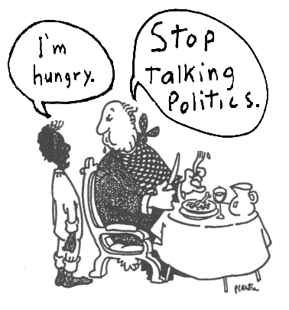
Analyzing the 2008 Electoral Advertisements

Purpose: Why are we doing this?

Americans are constantly bombarded by political rhetoric, particularly during election years. Much of this rhetoric seems empty and meaningless; what does it mean to say that "I'm for America," or "I'm running on a platform of family values?" The purpose of this project is to help you learn about political rhetoric. You will learn to identify the different types of appeals, analyze political jargon, and consider how politicians use rhetoric to influence voters. A good understanding of political rhetoric is an absolute necessity for citizens in a democracy.

Assignment: What exactly do you want us to do for this project?

First, visit http://livingroomcandidate.org and select a political commercial. You may select any commercial for any candidate. Your 1000-word essay should do the following: (a) DESCRIBE the commercial and its historical/political context, (b) DETERMINE the intended audience, then IDENTIFY the types of appeals and issues addressed in the commercial, and (c) EVALUATE the effectiveness of the commercial (Ethos, Pathos, Logos, Logical Fallacies). You do NOT need to perform these tasks in the order they appear above. Organize your paper in a logical and readable manner. The commercial will be your PRIMARY source; you also need at least two other SECONDARY sources to support your arguments or supply additional material. These secondary sources can be newspaper or magazine articles, political websites, or political or rhetorical texts. You must cite whatever additional materials you use in this project using either MLA formatting. You can find information about citing sources in your textbook.

Please Note: You are not being asked to judge whether the values in the commercials are right or wrong; you are judging whether the commercial is rhetorically effective in persuading a particular audience.

Audience: Who are we writing this for?

Your audience for this project is composed of other citizens that want to be informed voters. You may choose a more specific audience, such as a group of democrats or group of republicans, but you should address these groups in an intelligent and professional manner. Treat your audience with care and respect.

Readings: What should we read to prepare for this assignment?

TBD

Additional Help: This is by no means an exhaustive list

Evaluating Resources (USF Libraries)
http://web.lib.usf.edu/ref/instruction/eval.html

Critical Evaluation of Resources (UC-Berkeley)
http://www.lib.berkeley.edu/TeachingLib/Guides/Evaluation.html

Critically Analyzing Information Sources: http://www.library.cornell.edu/olinuris/ref/research/skill26.htm

The Good, The Bad, and The Ugly: Why it is Good to Evaluate Web Resources:
http://lib.nmsu.edu/instruction/evalcrit.html
1

