The Perks of Being a Wallflower
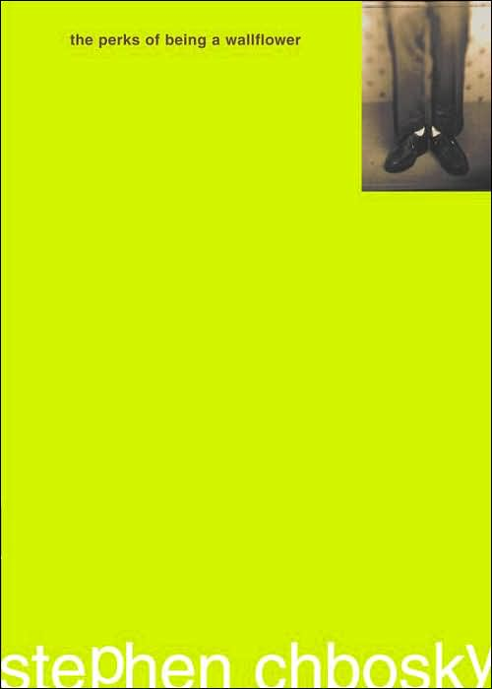
Reader’s Response Journal
Entry #2
Part Two

Directions:
• Respond to 10 questions for this entry. Each response should be accompanied with at least 3-5 sentences of commentary and placed in your Readers Response Journal. Please follow the suggested format.

1. Analyze and interpret: “The kids called the game “smear the queer.” I didn’t really think about what that means until now” (43).
a). What does “it” mean now?
b). What is ironic about the statement?

2. Unpack the significance of Brad’s repeated statement: “Man, I was so wasted. I don’t remember a thing” (44).

3. What are the underlying conflicts at play in the following statement: “Just pretend you’re passed out” (145)?

4. Analyze and interpret Charlie’s differing perspectives of love: “It’s like he would take a photograph of Sam and the photograph would be beautiful. And he would think …” (48).

5. On page 50, Charlie details the gist of Skinner rat experiments and says – “I don’t know the significance of this, but I find it very interesting” (50)
a). What is the significance of the story and how might it function as a metaphor within the novel?

6. Analyze and interpret: “I just hope I remember to tell my kids that they are as happy as I look in my old photographs. And I hope that they believe me” (53).

7. On page 55, Sam and Patrick agree to come to Charlie’s house for dinner. To what extent does Michael impact this event and Charlie’s reaction to their acceptance to the invitation?

8. With regards to the following scene, what understanding about life and family does Charlie gain from his grandfather – “My grandfather was crying. The kind of crying that is quiet and secret …” (59)?

9. What does the following excerpt reveal about Charlie’s character – “When we were getting ready to leave, I walked up to my grandfather and gave him a hug and a kiss on the cheek. He wiped my lip print …” (60)?

10. Analyze and interpret the “knowing” that everyone seems to have after Charlie reads a pem he received from Michael on page 66.

11. Go online and look-up the lyrics to the Beatles’ song “Something”
a). Based on the lyrics, why is this a perfect gift for Sam?
b). What does the gift reveal about Charlie’s character?

12. Analyze and interpret Sam’s comment: “I want to make sure that the first person you kiss loves you. Okay? (70)
a). What is ironic about this statement?
b). The novel frequently touches upon the theme of innocence and
knowledge. How does this theme create conflict in this scene?

13. The poem on pages 70-73 is the poem Charlie read to Patrick. It contains four stanzas. Based on a close diction analysis, how might each stanza symbolize or represent a stage in Charlie’s life?

14. Analyze and interpret Charlie’s internal conflict: “I walked over to the hill where we used to go and sled. There were a lot of little kids there. I watched them flying. Doing jumps and having races. And I thought that all those kids are going to grow up someday. And all of those little kids are going to do the things that we do. And they will all kiss someone someday. But for now, sledding is enough. I think it would be great if sledding were always enough, but it isn’t” (74)

15. Unpack what is going on in the following exchanges between Charlie and his mother:
-“Is it your Aunt Helen?”
- It was the way she said it that started me feeling.
-“Please don’t do this to yourself, Charlie.”
- But I did do it to myself. Like I do every year on my birthday
- “I’m sorry.”
a). Is “it” his Aunt Helen and what exactly is the “it?”
b). Why does Charlie “do this” to himself on his birthday?

16. Based on the surrounding context, what does the following gesture suggest – “Charlie, I would like you to drive the rest of the way to my mother’s house” (84)?

17. Charlie has bizarre and oftentimes irrational reactions. What is his emotive response to the following scenario: “The story keeps changing, but the main point is still the same. The guy died four days later in the hospital” (87)?

18. Analyze and interpret Charlie’s sentiment: “And I could feel what he felt on the night when he realized that if he didn’t leave, it would never be his life. It would be theirs” (88).

19. On page 89, the family visits Aunt Helen’s grave. Base don Charlie’s reasoning, why does his mom feel guilty?

20. On page 90-92, we finally learn how Charlie’s birthday and his Aunt Helen are inextricably linked. Explain this connection.

21. Breakdown Charlie’s self-conflict in the following scene and his emotive state: “Despite everything my mom and doctor and dad have said to me about blame, I can’t stop thinking what I know. And I know that my Aunt Helen would still be alive …” (92)

22. Explain the “thinking” Charlie is trying to avoid on page 93-94.

23. Analyze and interpret what Charlie means: “And you know that if you looked at these facts when you were happy, you would feel great because you are describing ‘unity’” (96)

