Of Mice & Men
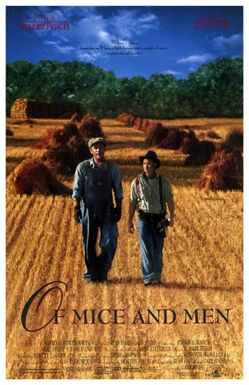
The Little Kiddies Edition

Directions:
☺This assignment is intended to help you synthesize and process what you have read thus far in the novel. To date, we have read the bulk of the book and the primary storyline is well established. To ensure that you are grasping the story, I’d like you to create a four page children’s book that summarizes the events and essential concepts in each chapter we’ve read. Listed below are the criteria:

□ Take four pieces of blank paper. Each sheet is to represent one chapter.
- The front will consist of a drawing that captures the principle theme of that chapter (Don’t worry; it doesn’t need to be fancy).
- The reverse side will need to contain an in-depth summary and analysis of the chapter (This is most important).

□ For each chapter I want you to consider the following in your written summary:
♦ Plot (what’s the action?). Provide a plot summary that highlights the key events in the chapter.

♦ Conflict (what are the struggles and how are they confronted/resolved?). In your plot summary discuss the conflicts that arise in each chapter

♦ Foreshadowing (what hints does Steinbeck give us of things to come? Example: In chapter one he characterizes Lennie as having hands like the paws of a bear. Lennie is also repeatedly told to return to the brush if trouble arises).

□ Incorporate at least one significant quote into each chapter summary. Be certain to explain why the quote is important.

☺ This assignment is worth 40 “Daily Points”

☺ You will only be given one class period in which to construct your book. What is not finished in class is homework.

☺ Golden silence rules must be observed. Failure to work quietly will result in your removal from class.

Work hard, ask questions, and have some fun!!

