If you Come Softly
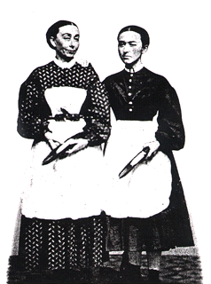
Critical Lens Essay

“The Bravest Of Individuals is the one who obeys his or her conscience

If you look around your neighborhood, in a high school, or even in the grocery store, you see people who have conformed to society’s idealistic persona of how you should look, sound, and even how you should act. Whether you should tan, have bleach blonde hair, or a size negative two figure – society is calling the shots. An individual who doesn’t follow society’s ideas, and has a mind of his or her own, is a leader. Whether you should have a normal hair color, keep your natural skin, and whatever size you are comfortable in – the brave ones amongst make these decisions with our hearts, not the prying of others. This idea is conveyed in the book If You Come Softly by Jacqueline Woodson.
Early in the book, Ellie falls in love at first sight with Miah. In the beginning, she doesn’t tell anyone, because she fears their reaction about her wanting to date a black boy. The racial conflict in this book takes an ironic turn when Ellie goes to her lesbian sister for support. Ellie talks to Anne about how she is dating a boy, but holds out on the black part. Ellie eventually says – “He’s Black Anne” – and Anne is silent. Thinking that since Anne had faced enough judgment about being a homosexual, she could support her and instead, it blows up in her face. It’s ironic that Anne could have faced so much criticism with her situation yet criticized her own sister for dating a black boy. Despite the reaction she gets from Anne, Ellie is brave, and follows her conscience and pursues the relationship with Miah.
Racial conflict is also present in the scene where Miah and Ellie are walking through Central Park holding hands. A woman looks at them and asks Ellie “Are you okay?” Ellie doesn’t think about it and just nods her hand. Later in the book she says, “I should have said something to them instead of just nodding my head.” Implying that she feels guilty about not standing up for them and proving there is nothing wrong with relationships of opposite races. Although Miah and Ellie were constantly judged by their peers, they stuck together until the end. Miah and Ellie were brave, and they followed their consciences and loved each other until the end

