Critical Lens Essay for If You Come Softly
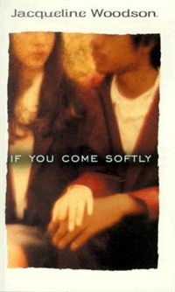

Your Task:
Write a critical essay in which you discuss If You Come Softly from the particular perspective of one of the statements listed below. In your essay, provide a valid interpretation of the statement, agree or disagree with the statement as you have interpreted it, and support your opinion using specific references to appropriate literary elements from the two works. You may use scrap paper to plan your response. Write your essay on separate sheets of paper:

Critical Lens: ONLY BASE YOUR ESSAY ON ONE OF THE FOLLOWING STATEMENTS
“The bravest of individuals is the one who obeys his or her conscience”
OR
“I like flawed characters because somewhere in them I find more of the truth”

GRADING CRITERIA: MAKING SURE ALL THE ESSENTIAL INGREDIENTS ARE INCLUDED
□ Provide a valid interpretation of the critical lens that clearly establishes your thesis statement and criteria for analysis
□ Indicate whether you agree or disagree with the statement as you have interpreted it
□ Write a catchy introduction that has a strong opening line
□ Make specific references to appropriate literary terms (theme, conflict, characterization, setting, point-of-view, etc)
□ Include some plot summary
□ Include at least 2 super specific textual references to illustrate how the lens works
□ Organize your ideas in a unified and coherent manner (Make Yummy Quotation Sandwiches and Flawless Syllogisms!!)
□ Specify the titles and authors of the literature you choose
□ Follow the conventions of standard written English

