Position Paper
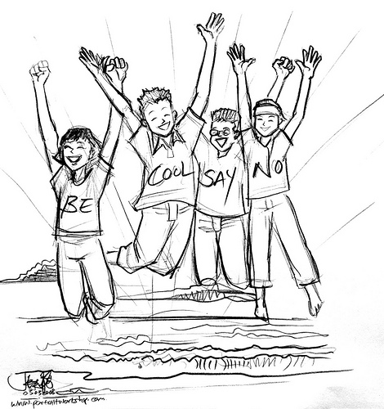

PROMPT:
☺ Randy and Melanie Bordelon, in the following editorial , play upon the semantics of the word ‘drug.’ In an essay of at least 2 pages in length, consider their position, critique their statements, and either agree or disagree with their stance. You may draw upon personal experience (your upbringing, parental influences, educational experiences, peer groups, etc.). Also feel free to use the library databases to help support your claims.
