 |  | Classroom
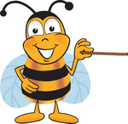 | Be Respectful | - Use appropriate language  - Use manners  - Work together  - Be helpful  - Keep hands, feet & belongings to yourself  - Wait your turn to speak
 | Be Responsible | - Follow directions  - Keep your work area clean  - Carefully handle school equipment and materials
 | Be Ready to Learn | - Be prepared  - Be on time  - Give your best effort  - Be positive  - Use “full body” listening  - Use time wisely
 | Be Caring | - Accept differences  - Be helpful  - Be kind & sensitive to the feelings of others  - Stick up for others  - Solve problems in a positive way  - Share
 | Be Trustworthy | - If you make a mistake, always tell the truth

