Author Study
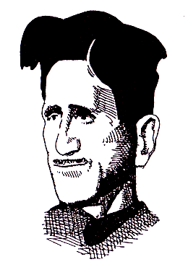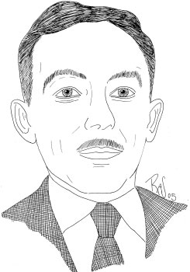
George Orwell & EB White
Directions
For this essay of 2-3 pages in length, choose one essay from either author’s packet and write a formal analysis of it. In your essay, consider how either Orwell or White crafts the text to reveal their overall message. Pay particular attention to the form, style, and structure of the piece
Proceed syllogistically

Adhere to the rules for constructing a stellar introduction

Embed your quotes

Provide sufficient textual support and analysis

