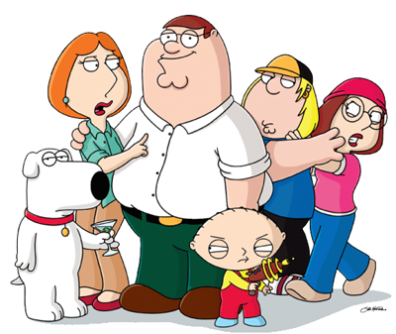

Assignment Overview:
Over the course of the year, you’ve tried your hand at performing rhetorical analysis on several occasions. Collectively, you’ve made great strides in covering your STD’s (Syntax, Tone, & Diction)as well as the piece’s ethos, logos, and pathos. Moreover, you’ve successfully touched upon theoretical components (dichotomy, binary, juxtaposition). With some of these pieces, however, we need to make sure that we analyze the social commentary of the work as well.

Oftentimes, literature says something about the social make-up of an era. Within this commentary, authors typically use satire, sarcasm, lampooning, parody, etc. This assignment is designed to help us construct fuller reads of this commentary.

What to Do?:
♦ Write a 2 page formal analysis of either the “Cool Whip” episode from the Family Guy, or visit www.hulu.com and deconstruct any episode you want from such shows as The Simpsons, The Cleveland Show, South Park, etc. If you choose to use Hulu, you’ll need to create an account (if you don’t have one). Also include the link to your episode when you submit your paper.

♦ Explain how the episode constructs meaning

♦ Thoroughly explain the social commentary of the piece as well as how the parodies, spoofs, sarcasm, etc. function in the work as a whole

♦ Proceed syllogistically

♦ Continue to grow and mature as a writer by working on your weaknesses

