Stylistic Analysis (Non-Fiction Author Paper)
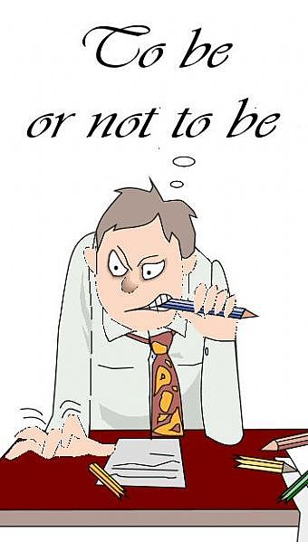
Instructions & Guidelines
Your job is to examine, in depth, the way your author fulfills her/his purpose in a text. You should look at both style and rhetoric including such elements as tone, specific diction, development of imagery and detail, syntax, and the formality or informality of the language, anecdotes, examples, juxtapositions, etc (to name a few). To thoroughly understand a text, you must see and make sense of the multifaceted ways the writer employs language to get the intended message across to you, the reader. The following list should give you an indication of how complex style analysis can be. As you are reading, pay attention to (and find examples of) …

Addictions  Affectations  Approaches  Biases  Characterizations  Discriminations  Eccentricities  Fears  Fixations  Hates  Idiosyncrasies | Inclinations  Loves  Mannerisms  Messages  Oddities  Opinions  Paragraphs  Peculiarities  Point-of-view  Predilections  Prejudices | Punctuation  Quirks  Routines  Sentences  Sentiments  Sympathies  Tendencies  Themes  Trends  Various “isms”  “Writerly” flourishes

This is a primary source “research” paper and you will be expected to follow the MLA format for documenting sources and citing examples. Further instruction in MLA will follow and MLA formats are also available online at www.owl.english.purdue.edu.

Your paper must be 8-10 pages in length, typed, double-spaced, conventional font

There are three components of the grade that you will receive:
a). Rough draft (4/10)
b). Final paper (5/10)
c). Oral presentation (1/10)

Late papers will be penalized 10%. I will not accept e-mailed papers

After the AP exam, class time will be dedicated to this assignment. You will be given time to finish your reading, organize your materials, begin your drafts and conference with your classmates and your instructor.

Good luck with your reading, your discovery and your writing.
Stylistic Analysis (Non-fiction Genre Paper)
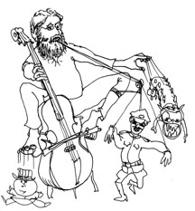
Instructions & Guidelines
A genre study is an opportunity for you, the reader, to examine how authors in a particular genre (historical memoir, addiction & recovery, animal ethics, scientific discovery, etc.) satisfy the purpose of the genre through their employment of rhetorical and stylistic strategies, including such elements as tone, specific diction, development of imagery and detail, syntax, the formality or informality of the language, anecdotes, examples, juxtapositions, etc (to name a few). To thoroughly understand a text, you must see and make sense of the multifaceted ways the writer employs language to get the intended message across to you, the reader. The following list should give you an indication of how complex style analysis can be. As you are reading, pay attention to (and find examples of) …

Addictions  Affectations  Approaches  Biases  Characterizations  Discriminations  Eccentricities  Fears  Fixations  Hates  Idiosyncrasies | Inclinations  Loves  Mannerisms  Messages  Oddities  Opinions  Paragraphs  Peculiarities  Point-of-view  Predilections  Prejudices | Punctuation  Quirks  Routines  Sentences  Sentiments  Sympathies  Tendencies  Themes  Trends  Various “isms”  “Writerly” flourishes

This is a primary source “research” paper and you will be expected to follow the MLA format for documenting sources and citing examples. Further instruction in MLA will follow and MLA formats are also available online at www.owl.english.purdue.edu.

Your paper must be 8-10 pages in length, typed, double-spaced, conventional font

There are three components of the grade that you will receive:
a). Rough draft (4/10)
b). Final paper (5/10)
c). Oral presentation (1/10)

Late papers will be penalized 10%. I will not accept e-mailed papers

After the AP exam, class time will be dedicated to this assignment. You will be given time to finish your reading, organize your materials, begin your drafts and conference with your classmates and your instructor.

Good luck with your reading, your discovery and your writing.

