Emerson’s Nature & A Walk in the Woods

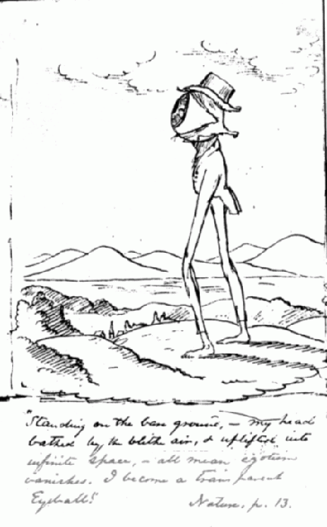

Cross Analysis Essay

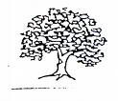For this essay of 4-5 pages you are to perform a cross analysis of both texts. This means that you should explore some of the salient similarities and differences of the text. In writing your essay, consider the following:
 Have Emerson’s tenets serve as the basis for your analysis

Although you don’t have to, it might be a good idea to explore the logical fallacies of the text

Your introduction needs to adhere to the rules we established in our last writing seminar with regards to constructing a thesis statement

Your 1st premises should frequently set you up to tackle both texts simultaneously

For your 2nd premise, you should have a blend of paraphrase and direct textual support

Limit your “to be verb” usage

Be cognizant of your sentence constructions

Visit your portfolio and try to make progress!!

