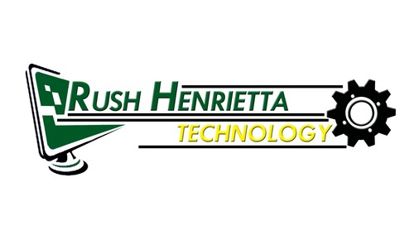
Roth Middle School
Technology Education
Grade 8
Mr. DeSimone

Units of Study: Projects

Unit 1 CAD Inventor 3D Assembly
Unit 2 Robotics & Automation Lego NXT
Unit 3 Mechanics of Motion CO2 Dragster
Unit 4 Energy & the Environment Solar Car & Wind Power Generator
Energyville

Within these units are a series of laboratory-based activities. These activities allow the student to experience a logical study of concepts related to hands on problem solving activities, which relate to everyday life. Within our 20 week class students will learn the skills that are the foundation of our Technology program in Rush Henrietta. You will also gain a better understanding of what choices are provided in our high school programs.

Each unit of study has three measures of evaluation

- Vocabulary, Research & Quiz
- Design Packet
- Project

Evaluation criteria

Structured quizzes (Castle Learning) and rubrics are included within each unit of study. Ultimately, it is our hope that your son / daughter will learn these major concepts.

*Critical Thinking Skills
*Develop Deductive/ Inductive Reasoning Abilities
*Develop Problem Solving Skills
*Access, Generate, Process and Transfer Information Skills

Contact Information

Please email me with at ddesimone@rhnet.org if you have any questions or concerns

You will also find a variety of resources posted on my web site
http://rhnet.org/webpages/ddesimone

