

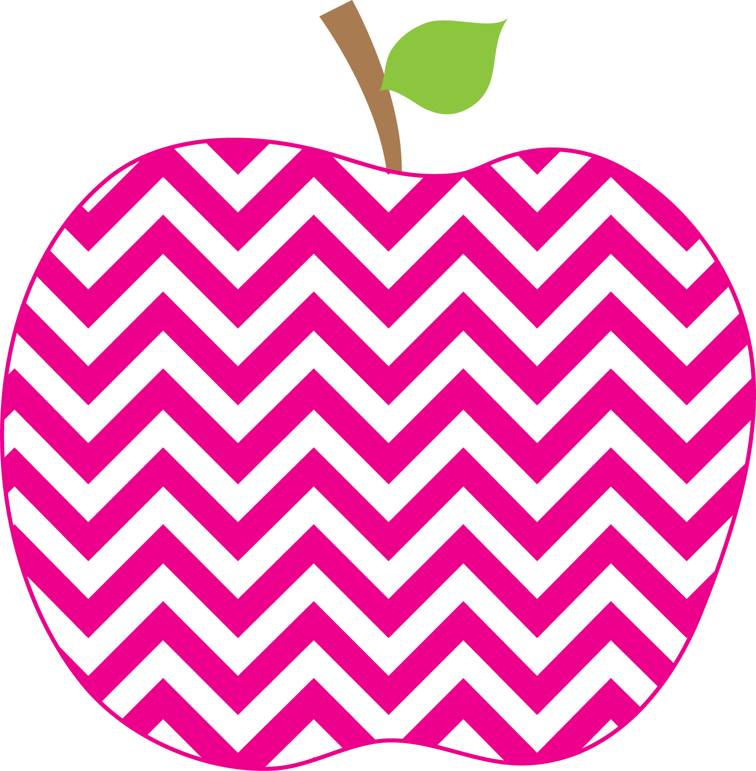



Mrs. Bagley’s Class Class Weekly
September 10 - 14

Reading: Students are learning the important behaviors in order for them to do their best independent reading. Each day they are working on building their stamina to be able to read/focus for a longer period of time.
Math: Students continue are using number bonds to learn the combinations of 6, 7, 8 and 9. They then use the number bonds to create number sentences.
Word Study: Student reviewed the Fundations lines (sky line, plane line, grass line and worm line) Students used these lines to practice the correct formation for writing the capitals and lower case letters. Students started learning the letter names, keywords and the corresponding sounds. So far we have learned; t, b, f, m, n, i, o, u, a, g, d, s. We will continue to focus on letter formation for capital and lower case letters.

Weekly Behavior Report for __________________________

Ready to Learn _________
Respectful _________
Responsible _________
Caring _________
Trustworthy _________
ME = Meeting Expectations NS = Needs Support (will have a message on the back of this or a phone call home)
Please sign and return this form. Add any comments or questions on the back. Signature _________________________
This Week’s Focus
Reminders
Bathroom use has improved and there have been less accidents. Spend time again this weekend reviewing the correct way to use the bathroom and wash their hands and hopefully next week will be even better! Having a waterbottle in the classroom has been great. Your children have been drinking water and helping keep their bodies healthy and hydrated!!
As a class, we are working on being respectful and talking when appropriate. We are a super chatty bunch. Any reminders at home would be greatly appreciated.
Students are doing well with snacks. Please talk to your child and see if they feel they need a snack. Many days we have sad or hungry friends that wish they had a healthy snack to eat. Please DO NOT send in juice or juice boxes for during the day. Save those for lunch or afterschool.
Feel free to contact me anytime ☺
Phone: (585) 359-5430
E-mail: abagley@rhnet.org
Webpage: http://www.rhnet.org/webpages/abagley
Snack
Contact Information

