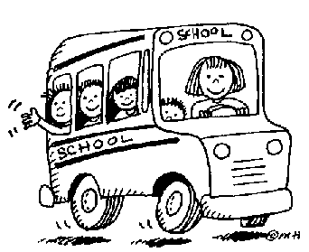
Check out our classroom website at http://www.rhnet.org/webpages/nlamartina/
Mrs. LaMartina’s Classroom News September 17th-21st
A Peek At The Week 
Word Study/Fundations – Word Study Words: the, a, and, as, is
Fundations is reviewing the importance of letter formations, pencil grip, and letter-sound recognition. We will move through the alphabet before jumping into new vocabulary words, and trick words.

Daily 5 – We have begun to practice Reading to Self. We have book boxes filled with books that are “Good Fits”. We are building our reading stamina, and recording books that we read. We will move into some Word Work to practice our Kindergarten sight words, and being working with our First Grade sight words.

Writing – We start the year reviewing the importance of writing conventions. We will practice Capitals, Periods, Spacing, and Organization.

Math – We started our Module 1 on the first day of school! We will practice number bonds using numbers 1-10, decompositions of numbers, and begin some work with story problem solving strategies.

Social Studies- We have begun our unit on Rights, Roles, and Responsibilities in the classroom, school and our communities. We will discuss rules in the different parts of the school, what it means to be a responsible citizen and the rights we have.

Books We Enjoyed Last Week

- Dog Days of School
- Wemberly Worried
- Being a Citizen
- I have Rights

Important Information 

Parents!

Please remember to have your child give you their folder each night. This is an important way for me to get in touch with you and communicate important things that will be coming up in school.

If you have not already signed up for my REMIND site, be sure to review the paper that was sent home last week. This will be a good way for me to reach all of you quickly and easily.

Thank you,
Mrs. LaMartina



9/21 - Ice Cream Social 6:00-7:30

9/28 - Fyle Movie Night

10/1-10/5- Safety Week

10/5- No School/ Superintendent Conference

10/8- No School/ Columbus Day

