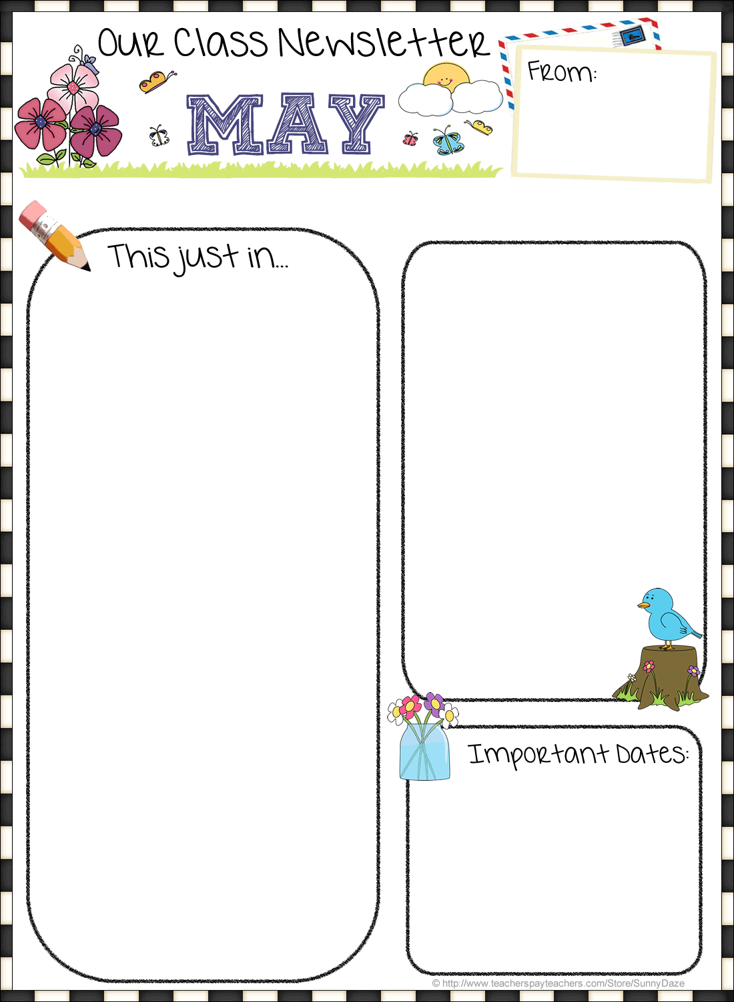

20188

BIRTHDAYS

Adrianna-May 19th

I would also like to celebrate summer birthdays as well. If your child’s birthday is in the summer and you would like to come in and celebrate with them please email me so we can arrange something ☺

**May’s**

**Specials Schedule:**

*The weeks in this month start with:*

May 7th: C Day

May 14th: D Day

May 21st: A Day

May 29th: B Day



Our class is split up for specials each day. Use the table above to determine your child’s schedule. Your child knows what color group they are in.

Our class is split up for specials each day. Use

the table above to determine your child’s schedule.

Your child knows what color group they are in.

**Home-School Communication:**

***Save this important date:***

Our 3rd Grade play, It’s **A Hit!,** is Thursday, May 24th. There will be two showings, one in the afternoon at 1:15pm and one in the evening at 6:30pm. We’re a TEAM, so please make your best effort to have your child attend both performances considering many of the third graders have a part.

**As the weather gets warmer**, your child will be going out for recess more frequently. Please remember to dress them appropriately for the weather and that sneakers are required for outside play.

***Wishing all the moms of our class a very Happy Mother’s Day!***

Trait of the Month for May:

***Be Trustworthy*** ☺

**Contacting**

**Mrs. Popielarz**

• **Email:** apopielarz@rhnet.org

• **Phone:** (585) 359-5430

• **Classroom** **Website:** www.rhnet.org/webpages/apopielarz/

Fyle Elementary   
Mrs. Popielarz  
Third Grade



**ELA/Writing:**

Students have just completed a research project about the country of Kenya. They researched information on the school databases about the geography, culture, climate, government, and economy of Kenya. They then used their research to create a slide show presentation which they will be presenting to the class. I had students create these presentations to help prepare them to complete an upcoming independent research project in Social Studies. The students have chosen a country of their own to research and create a presentation on. In ELA students have also been learning about how to determine the theme of a story using clues from the text to support their choice.

**Math:**

We have started on our final (LONG!) unit. The unit as a whole focuses on solving word problems, but we will also be learning about:

* Attributes of Two-Dimensional shapes
* Finding the perimeter of a shape
* Finding the area of a shape (review)

**Science/Social Studies:**

**Animal Interdependence:** We are currently studying an ant colony in our classroom, watching them closely to see how they work together to survive! Ask your child about the observations they have made. We will continue this unit by learning about habitats, ecosystems and how people can help to protect and preserve the environment

**Life Cycles and Heredity:** Along with our ants we also got to observe caterpillars turn into butterflies. The students will soon be learning more about the life cycle of a butterfly, as well as the life cycle of other animals. They will also learn how the traits of different animals are important to their survival.

**Important Dates:**

Wednesday, May 16th – **Culture/ community Fair** 6pm-730pm

Friday, May 18th - **Game Night** 6:30pm – 8:00pm

Monday, May 21st and Thursday, May 24th - **MATH & ELA MAPS Testing**

Thursday, May 24th - **Grade 3 Play** 1:15pm and 6:30pmand

**Grade 3 Art Show,** starting at 6pm

Monday, May 28th - **No School - Memorial Day**