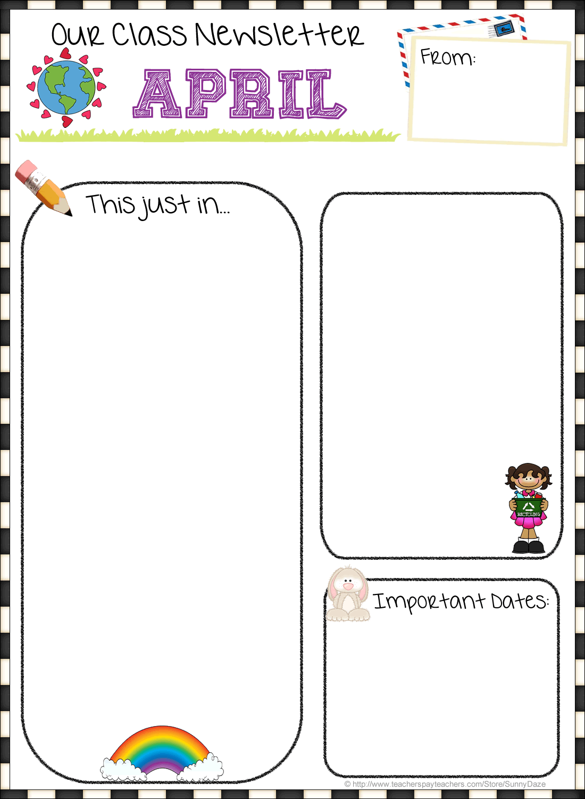

Our class is split up for specials each day. Use the table above to determine your child’s schedule. Your child knows what color group they are in.

**Home-School Communication:**

The students did a great job this month with the ELA state testing! The math state test is coming up soon. It will be on May 1st and May 2nd. Please make sure your child gets a good night sleep the night before so they are well rested and prepared.

**The Third Grade Play is COMING!!!**

Please be sure to mark your calendar for our special performance on May 24th at 1:15 and 6:30 pm. The kids are working hard and will be very excited to show you their hard work that evening.

Trait of the Month for April:

***Be Responsible***

**Email:** apopielarz@rhnet.org

**Phone:** (585) 359-5430 **Classroom** **Website:** www.rhnet.org/webpages/popielarza

/

BIRTHDAYS

Annabel: April 21st

☺

**April’s**

**Specials Schedule:**

*The weeks in this month start with:*

April 9th: C Day

April 16th: D Day

April 23rd: A Day

April 30th: B Day



**Contacting**

**Mrs. Popielarz**

2018

Fyle Elementary   
Mrs. Popielarz  
Third Grade

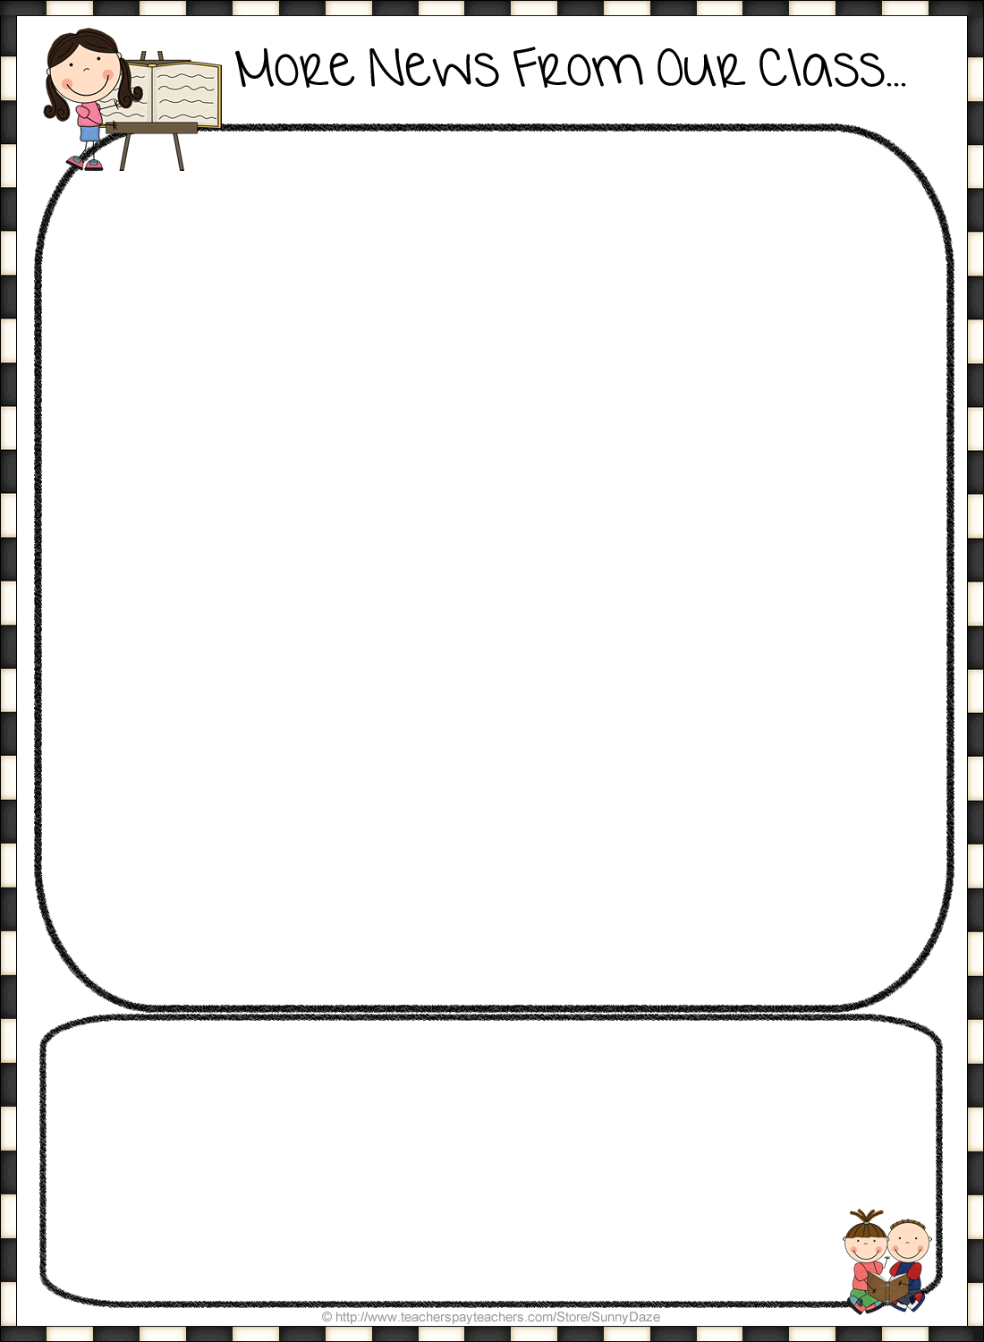

**Upcoming Important Dates:**

**Friday, April 20th Report Cards come home**

**May 1st and 2nd Math state test**

**May 16th Culture Fair, Time will be sent soon**

**May 24th Third grade musical, 1:15 & 6:30 PM**

**ELA/Writing:**

Our ELA focus in April is on opinion writing and expressing a point of view. We have been working on learning the format of opinion writing, providing a short response with a claim and two to three supporting details. Students also are completing a creative writing assignment pretending they are a child from Kenya and are describing what a day in their life is like. These strategies are being incorporated into our writing block, as well as our social studies units. Students will also be doing independent research on the country of Kenya and creating presentations to share what they learned. This will help prepare them for the capstone project they will be completing next month. More about that will be in next month’s newsletter.

**Math:**

We recently began Unit 6 in math. Students are collecting and displaying data using different types of graphs that we are learning about. The students are learning how to create a picture graph and a bar graph using a number scale, a data set, and several categories. We also are focusing on measuring in inches and fractions of an inch and creating a line plot using that data. As always, students should continue to practice math skills using IXL to build greater understanding and mastery of 3rd grade concepts and skills. Mastery of math facts is the key!

**Science/Social Studies:**

We just completed our Social Studies unit on Kenya and are now moving on to a new Science unit, Interdependent Relationships. This unit focuses on how different life-forms rely on each other to survive, as well as the impact of the environment on living things. We will study an ant colony, biomes/ecosystems, and even learn about fossils! Students also will be observing caterpillars as we prepare for our next science unit on life cycles.